- OZR 203 HOSPITAL BED (Metal Side Rail)

- • Electrical operated backrest and legrest movement.
• Patient handset.
- • Retracting backrest for advanced comfort, less pressure.
- • Lockable and tuck away metal side rails
- • Easy adjustable knee break position.
- • Removable head and foot boards.
- • 125 mm directional lock castors.
- • Electrostatic painted metal frame.
- • Metal sheet sleep surface
- • Height adjustable IV pole.

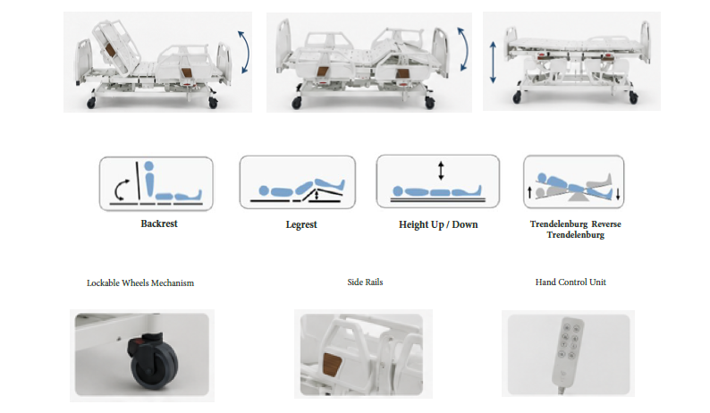

TECHNICAL SPECIFICATIONS  Overall Dimesions: (Max.) | 105 – 216 cm
Footrest Angle (Max.) | 0° – 35°
Height range without Mattress | 42 -78 cm
Trendelenburg | 12°
Reverse Rrendelenburg | 12°
Mattress Platform (ABS) | 90 x 200 cm
Castor Diameter | 12,5 cm
Safe Working Load | 220 kg

